Confidentiality Level |  | PU - Publish | TC ID / Revision |  | 00304426/D
Document Status |  | Document Released | Document No. |  | N/A
OBS code |  | 911
PBS code |  | RA1.L1.L1_2.PA.JIT
Project branch |  | Engineering & Scientific documents (E&S)
Document Type |  | Specification (SP)
[RSD product category B]

Optical cross-correlator system
for locking 1030 nm and 820 nm oscillators
TP20_100



Keywords
optical synchronization, timing jitter

 | Position |  |  | Name
Responsible person | L1 Allegra Laser Scientist |  |  | Roman Antipenkov
Prepared by | L1 Allegra Laser Scientist |  |  | Roman Antipenkov

RSS TC ID/revision | RSS - Date of Creation | RSS - Date of Last Modification | Systems Engineer
022786/A.003 | 20.07.2021 | 20.07.2021 | D. Hanusková
Reviewed By
Name (Reviewer) | Position | Date | Signature
Jack Naylon | Group leader of Laser Control Systems | Via TC
Pavel Bakule | Group Leader of L1 Allegra Laser | NOTICE (cat. B)
Viktor Fedosov | Group Leader of Quality and Planning | Via TC + e-mail
Veronika Olšovcová | Group Leader of Safety | NOTICE (cat. B)
Ladislav Půst | Group Leader of Installations | Via TC
Roman Kuřátko | Head of Department of Building Infrastructure and IT | NOTICE (cat. B)
Radek Toman | Lawyer | Via e-mail
Lucie Kaletusová | Cleanroom Group Leader | NOTICE (cat. B)
Luboš Nims | Electrical Engineering Group leader | Via TC


Approved by
Name (Approver) | Position | Date | Signature
Pavel Bakule | Group Leader of L1 Allegra Laser | Via TC
Roman Antipenkov | L1 Allegra Laser Scientist | Via TC

Revision History / Change Log
Change No. | Made by | Date | Change description, Pages, Chapters | TC rev.
1 | R. Antipenkov | 25.6.2021 | Draft | A
2 | R. Antipenkov, D. Hanusková | 29.06.2021 | Version for review | B
3 | V. Fedosov, R. Toman | 08.07.2021 | Final version | C
4 | R. Antipenkov | 20.07.2021 | Re-released version after author’s changes | D

Table of Content

1. Introduction 4
1.1. Purpose 4
1.2. Scope 4
1.3. Terms, Definitions and Abbreviations 4
1.4. Reference documents 5
1.5. References to standards 5
2. General Functional, Performance and Design requirements 5
3. Transportation and Installation requirements 7
3.1. General requirements 7
4. Safety Requirements 8
5. Quality Requirements 9
5.1. General Quality Requirements 9
6. Requirements verification for the Supplier 9
6.1. General requirements verification for the Supplier 9
6.2. Quality report 10
6.3. Acceptance 10

Introduction

Purpose
This Requirements Specification Document (RSD) lists the technical requirements and constraints on product applying in ADONIS FSYNC program of ELI project. This can lead to the identification of product interfaces with the ELI science based technology and ELI building facility. This RSD also acts as the parent document for the technical requirements that need to be addressed in lower-level design description documents.

Scope
This RSD contains all of the technical requirements: functional, performance, operational & design, transportation & installation, safety & quality requirements for the following product: Optical cross-correlator system for locking 1030 nm and 820 nm oscillators (further BOC).

The product is an integral part of the L1-FSYNC laser system. This product is registered in the PBS software under the following PBS code: RA1.L1.L1_2.PA.JIT.

This product is product Category B. Category B does not require any design modifications to the product. Verification (test) program shall be decided and performed on a case-by-case basis.

Terms, Definitions and Abbreviations
For the purpose of this document, the following abbreviated terms are applied:

Abbreviation | Meaning
CA | Contracting Authority (Fyzikální ústav AV ČR, v. v. i.)
E1-E6 | Experimental halls 1-6
ELI | Extreme Light Infrastructure
FD | Functional Demonstration
L1-L4 | Laser Halls 1, 2,3,4
RA1-RA6 | Research activity 1-6
RSD | Requirements Specification Document
T | Test
BOC | Optical cross-correlator system for locking 1030 nm and 820 nm oscillators

Reference documents

Number of document | Title of document
RD-01 | Laser beam parameters

References to standards
If this document includes references to standards or standardized / standardizing technical documents, the CA allows/permits also another equal solution to be offered. If a supplier offers another equal solution the CA shall not reject its bid, once the supplier by appropriate means in the bid proves that the offered supplies, services or works meet in an equivalent manner the requirements including references to standards or technical documents.

General Functional, Performance and Design requirements

The BOC is intended to be incorporated into the laser system as a part of the stabilizing loop with an option to be used as the out-of-loop measuring device. The BOC signal will be used as the input to the SRS SIM960 PID controller.
The BOC will have 1030 nm and 820 nm pulses at 80 MHz repetition rate at the input (see attachment RD-01) and shall provide a quasi-DC analog signal at the output with voltage linearly proportional to the timing delay between the input pulses.

REQ-032381/A
The device dimensions shall not exceed the dimensions of 80 cm x 40 cm x 40 cm (L x W x H). Excluding cables and fibers.
REQ-032382/A
The device shall have at least three analog signal outputs: 1) main balanced output 2) monitoring of the first photodetector signal level; 3) monitoring of the second photodetector signal level.
REQ-032383/A
The signal outputs shall be coaxial 50 Ω SMA female and compatible with a 1 MΩ load termination with +/- 10V operating range.
REQ-032384/A
The BOC timing detection sensitivity of the main balanced output shall be at least 5 mV/fs at 1 MΩ load impedance for the nominal input pulse parameters (RD-01).
NOTE: The test results will be listed in the Quality report.
Verification method: T – test

REQ-032385/A
The BOC timing detection sensitivity of the main balanced output shall be stable within +/- 20% of its nominal value for input alignment deviations of +/- 100 μrad pointing and 5% beam diameter centering, and within standard lab temperature deviations of +/- 1 Celsius for the nominal input pulse parameters (RD-01).
NOTE: The test results will be listed in the Quality report.
Verification method: T - test
REQ-032386/A
The intrinsic system’s noise floor at operational settings shall be less than 0.4 fs RMS in the range from 10 Hz to 100 kHz.
NOTE: The test result is sufficient for the type of the detector and does not have to be tested for the specific device.
Verification method: T - test
REQ-032387/A
The 3dB signal bandwidth shall not be smaller than 100 kHz.
REQ-032388/A
The residual voltage ripple arising from the 80 MHz input pulse train shall be less than 0.1% peak-peak of the output voltage.
NOTE: The test results will be listed in the Quality report.
Verification method: T – test
REQ-032389/A
The dynamic range within which the BOC is capable of providing a linear feedback signal within +/-20% of its nominal peak sensitivity shall be at least 200 fs with the given laser parameters (RD-01).
NOTE: The test results will be listed in the Quality report.
Verification method: T – test
REQ-032390/A
The device shall operate on the European standard mains 230 VAC voltage. The mains cord shall be compatible with CEE 7/5 standard socket.
REQ-032391/A
The BOC shall be alignment free: the BOC system shall require only alignment of the beam pointing into the system at the moment of installation and shall maintain its functionality and working parameters as long as beam pointing does not deviate by more than +/-100 microradians and beam centering does not deviate by more than 5 percent of the beam diameter.
NOTE: The test results will be listed in the Quality report.
Verification method: T - test

Transportation and Installation requirements

General requirements

REQ-032392/A
The transportation to the final destination and the installation of the technologies and the instruments shall be conducted by the Supplier.
REQ-032393/A
The Supplier shall ensure that its activities at the premises and the installation of devices will be performed without contaminating the place of installation unnecessarily. The premises include rooms with normal cleanliness and cleanrooms of class 7 according to ČSN EN ISO 14644 (equivalent to EN ISO 14644).
REQ-032394/A
The transportation and Installation procedures shall be discussed and can be reviewed by the CA’s installation officer.
REQ-032395/A
All participants to the installations shall undertake a lecture by the CA regarding safety, cleanliness, protection of the environment and working methods before starting their activities on the premises. The content of the lecture shall be adequate to the working area and the work activities expected.
REQ-032396/A
The Supplier shall allow the CA to supervise the activities related to the transportation and installation.
NOTE: Any acts of supervision shall not mean that the CA assumes additional liability of any kind exceeding its liabilities according to the contract.
REQ-032397/A
The technologies and instruments shall be delivered in protective package preventing damage and contamination and a minimum of two plies separate clean packaging. The technologies shall be cleaned and packaged in compliance with the cleanliness of class 7 according to ČSN EN ISO 14644 (equivalent to EN ISO 14644).
REQ-032398/A
The Supplier and the CA shall agree on the cleaning method to clean devices without decreasing the devices' performance and to avoid contamination of clean space.
NOTE: The cleaning methods may use high temperatures (baking out), high gas flow (dry air) and specialized chemical cleaning liquids (alcohol, Isopropyl alcohol, demineralized water).

REQ-032400/A
The clothing used at the installations shall conform to ČSN EN ISO 14644 (equivalent to EN ISO 14644) international standards of cleanliness and the standards of the clean rooms class 7, which the installation is processed in, in order to avoid contamination of the room and the equipment room.
REQ-032401/A
Every transportation and installation tools and equipment entering the clean rooms shall be cleaned and reviewed by the CA’s approved methods. The Supplier and the CA shall agree on the cleaning method of clean tools and equipment used at the installation without decreasing their performance or safety.
NOTE: Some tools can be provided by the CA upon agreement.

Safety Requirements

REQ-032406/A
The supplier shall supply a Declaration of Conformity for each product type if the appropriate legislation determines the supplier's obligation to have a Declaration of Conformity for the purposes of a Device sale in the Czech Republic. In such a case the Declaration of Conformity shall comply with:
- Act No. 90/2016 Coll., as amended
- Act No. 20/1997 Coll., as amended
- The equivalent legal regulation of another EU member state so that the conditions for the sale of the product in the Czech Republic are met, and/or
- the relevant EU/EC regulation
NOTE: The compliance with these obligations will be demonstrated by the (EU/EC) Declaration of conformity, other relevant documents and the CE/CCZ marking, if required by the relevant regulations. If a delivered product is not required to assess conformity according to specific legislation, the supplier declares by concluding the contract that the product complies with the general safety requirement of EU Directive 2001/95 / EC on general product safety and that the supplier duly complies their obligations under this legal regulation.

Quality Requirements

General Quality Requirements

REQ-032407/A
The Supplier shall provide the Product Manual as part of the delivered System. Completeness of the Manual shall be approved by the CA. The Manual shall include the instructions and descriptions regarding the following procedures:
- transport, handling, storage, disassembling and cleaning;
- installation;
- safe operation, maintenance and disposal procedures;
- description of cable wires or connector pins;
- list of spare parts, specialized tools, equipment and materials for proper maintenance or repair (if relevant);
NOTE: The manual can be supplied in the hardcopy or PDF formats.
REQ-032408/A
The Supplier shall provide information of outgoing check control of the Product. At least this information shall comprise a report about execution of outgoing check and fulfillment of the technical requirements defined by the product RSD, and completeness of the product.
REQ-032409/A
The Supplier shall establish and maintain a nonconformity control system compatible with ČSN EN ISO 9001 (equivalent to EN ISO 9001).

Requirements verification for the Supplier

General requirements verification for the Supplier

REQ-032420/A
Verification process (acceptance) of deliverable product shall be performed according to requirements defined in corresponding chapter (verification/acceptance).

REQ-032421/A
The Supplier shall define a test plan including: specification of how requirements will be tested and when the test program shall be implemented.

Quality report

REQ-032410/A
All tests´ results shall be included in the Quality report, except for standalone Test report (see REQ-032386/A).
REQ-032411/A
Verification by Test (T) shall consist of measuring product performance and functions under representative simulated environments.
REQ-032412/A
The analysis of data derived from testing shall be an integral part of the test and the results included in the test report.
REQ-032413/A
The test report (protocol of the measurement) shall be made by the Supplier and approved by the CA.
NOTE: The content of the Test Report shall be agreed by the CA.
REQ-032414/A
When the test objectives include the demonstration of qualitative operational performance (functional demonstration), the execution shall be observed and results recorded.
NOTE: Functional demonstration is a subset of test.

Acceptance

Acceptance will be carried out by the CA on the installed and complete product.

In case of successful acceptance phase the CA shall provide to the Supplier signed acceptance protocol. In case of unsuccessful acceptance stage the CA shall provide to the Supplier Nonconformity Report (NCR) and ELI nonconformity control process shall be applied (see REQ-032409/A).

REQ-032415/A
The Acceptance phase (as defined in the Contract) shall demonstrate the following:
- Final product has been successfully verified by the Supplier and this process has been documented in an appropriate way (through Quality report);
- All detected nonconformities have been solved in accordance with REQ-032409/A
- The final product is free of fabrication errors and is ready for the intended operational use (see, REQ-032408/A).

Confidentiality Level |  | UC - Unclassified | TC ID / Revision
Branch |  | E - Engineering | Document Status |  | InReviewProcess
Level |  | Verification (E)
Document Type |  | Report
PBS Code |  | RA1.L1_2
WBS /OBS Code |  | 3.1
RD-01 Laser beam parameters

Keywords
Specifications, laser parameters

 | Position |  |  | Name
Prepared by | L1 Allegra Laser Scientist |  |  | Roman Antipenkov

Table of Content

1. General description of the input beams 2
2. Femtosource Rainbow laser parameters (Input 1) 2
3. Origami laser parameters (Input 2) 5

General description of the input beams
This document describes the parameters of the laser beams, that shall be used as input for the balanced optical cross-correlator (BOC).
The BOC shall have two beams at the input. The beams are propagating in free space and are collimated to 2-3 mm beamsize with typical Gaussian beam diffraction.
The main beam parameters are summarized in the Table 1 below:

Table 1. The nominal input beam parameters for the BOC
Parameter | Input 1 | Input 2
Laser source | Ti:Sapphire oscillator (Femtosource Rainbow, Femtolasers Produktions GmbH) | Yb doped fiber oscillator (Origami, OneFive) + YDFA (PYFA, Keopsys)
Central wavelength | 820 nm | 1030 nm
Pulse duration | 150 fs (± 20 fs) | 300 fs
Transform limited pulse duration | 7 fs | 270 fs
Rep. rate | 80 MHz | 80 MHz
Average power | 30 mW | 30 mW
Residual locked oscillator phase noise jitter integrated from 10 Hz to 1 MHz) | <200 fs | <100 fs

Femtosource Rainbow laser parameters (Input 1)
Femtosource Rainbow laser is a commercially available broadband Ti:Saph oscillator manufactured by Femtolasers Produktions GmbH. The output of the laser is 160 mW at 80 MHz repetition rate. The spectrum of the laser is shown in Fig. 1. The laser beam is split by 80/20 beamsplitter, and 20 % is sent as Input 1 into the BOC. The available power budget for Input 1 can be increased in the spectral regions from 650 nm to 750 nm and from 920 nm to 980 nm by implementation of a custom beamsplitter. If such beamsplitter is needed, it shall be provided by the supplier as part of the BOC delivery.

Figure 1. The output spectrum of the Rainbow oscillator.

The beam is collimated and propagates ~10 meters in air from the oscillator output to the BOC. The beamsize at 2.5 meters from the oscillator output is D4σ = ~2.8 mm and the beamprofile is shown in the Fig. 2 below:

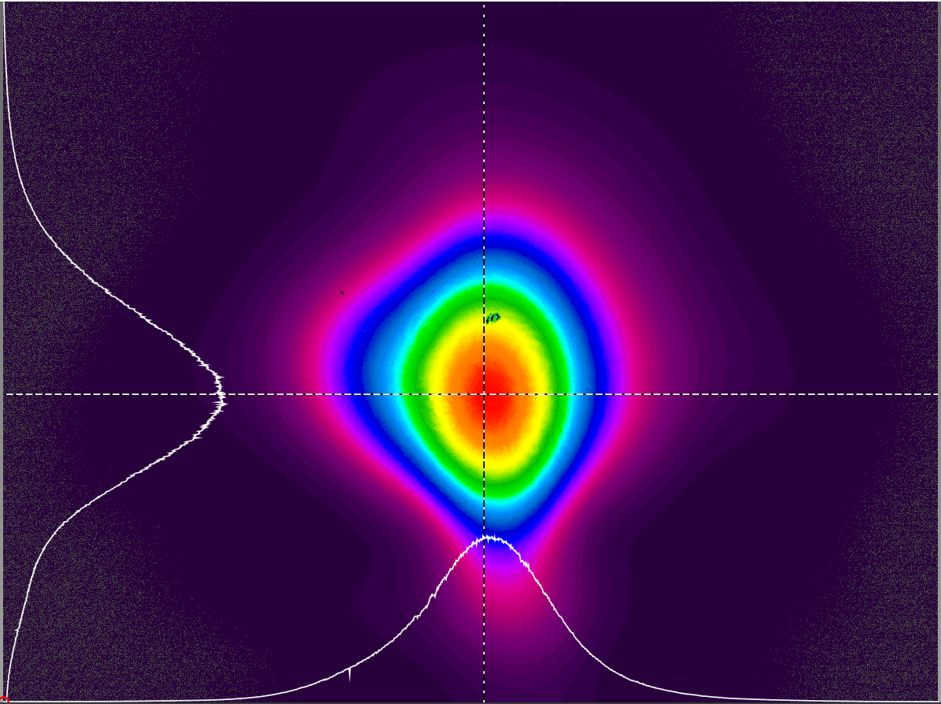
Figure 2. The beamprofile of Rainbow oscillator 2.5 meter away from the output.

The main contribution to the dispersion of the pulses comes from the propagation in air and from the beamsplitter used to split the portion of energy into Input 1.

The oscillator repetition rate and phase are locked to the external 960 MHz reference signal through the 12th harmonic of the repetition rate signal, and using SRS SIM960 PID controller for the locking feedback loop. The phase noise of the locked oscillator together phase noise measurement of the 960 MHz RF reference signal using Holzworth HA7062B phase noise analyzer are presented in Fig. 3. After subtraction of the RF reference noise contribution, the Rainbow oscillator measured jitter in the frequency range 1 Hz – 10 kHz was below 130 fs.

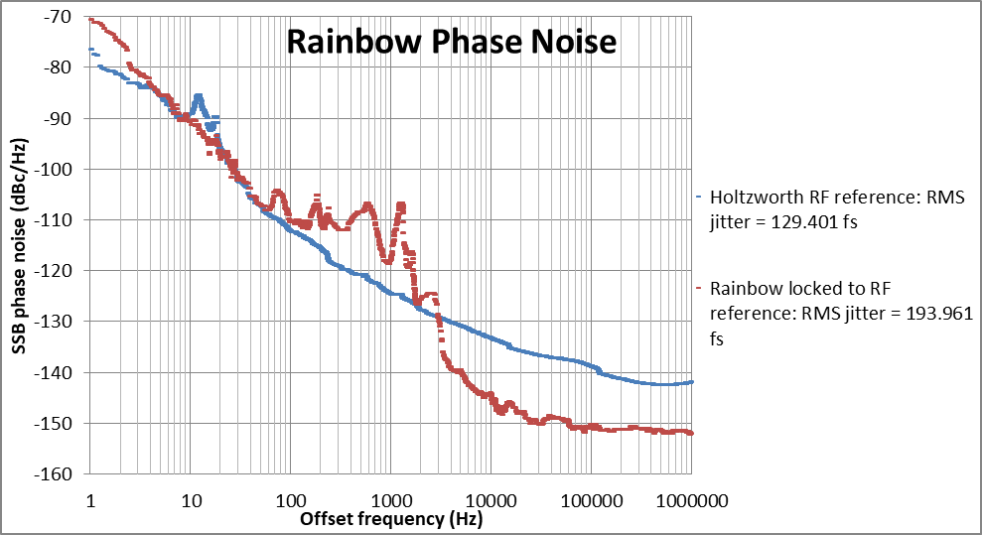
Figure 3. Phase noise measurement of locked Rainbow oscillator (red line) and RF reference (blue line).

Origami laser parameters (Input 2)

The 1030 nm beam is produced in the branch, which is seeded by the Origami fiber oscillator. The pulse goes through the CFBG stretcher and then is amplified in the fiber amplifier (Keopsys). The amplified beam is coming out of the single mode PM fiber and is collimated to D4σ = 2.5 mm. The beamprofile is shown in Fig. 4.

Figure 4. The output of the 1030 nm branch after the fiber collimator.

The beam is then sent into the grating compressor where it is compressed to ~300 fs. The pulse duration is defined by the compressor throughput bandwidth, which results in ~14 nm full width at 1% level.
The beam is then split by 50/50 beamplitter, and half of the power (~30 mW) is used for the BOC Input 2.
The oscillator is phase locked in the similar manner as Rainbow oscillator using the same 960 MHz reference clock signal and SRS SIM960 PID controller in a feedback loop. The residual measured phase noise is depicted in Fig. 5.

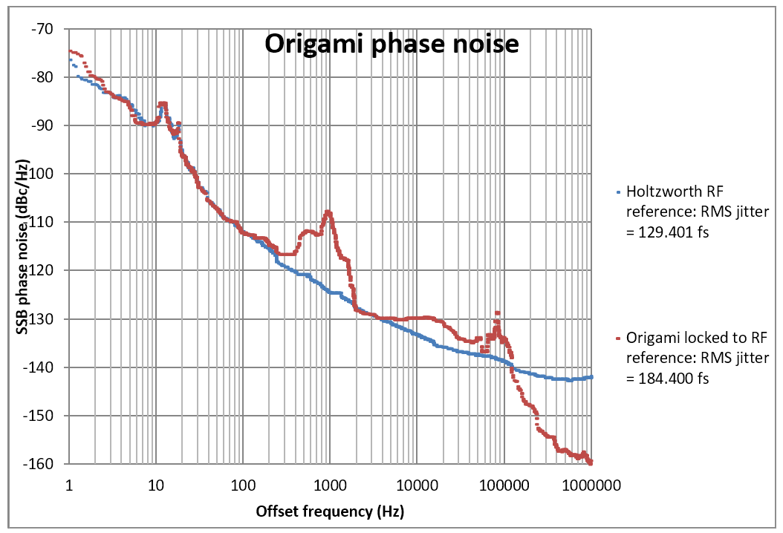
Figure 5. Phase noise measurement of locked Origami oscillator (red line) and RF reference (blue line).

After subtraction of the intrinsic RF phase noise form the measurement, the Origami phase noise jitter contribution integrated in the range from 1Hz to 100 kHz was well below 100 fs.

